|  |
| --- |
| Circle Language Spec: Interfaces |

## New Command with Interface Parameter

The New command was introduced in the *System Objects* chapter, having an optional Class parameter:

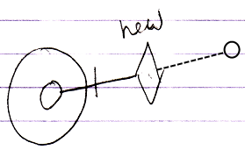

But now also the Interface can be specified upon creation of an object. This gives the New command an extra implementation:

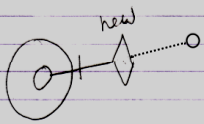

Now the New command’s Interface parameter is filled in. The new object will have a fixed interface, but the object does not have a class. This means the Publics are fixed by the interface, but an implementation is free to fill in.

You do not need to set both Class and Interface parameter of the New method, because if the Class parameter is set, it determines the Interface too.

It is also not required to set either parameter, because that will create an empty object in which you can put arbitrary content, that is not bound to a class or interface at all.